Root Mean Square Propagation

Introduction
The Root Mean Square Propagation (RMSprop) is an adaptive learning rate optimization algorithm by adjusting the learning rate for each parameter based on a model’s gradient history. Its popularly known in the machine learning community from being introduced by Jeffrey Hinton during one of his lectures and not via a published, formal, peer-reviewed academic paper. This algorithm predates the widely-used Adam optimizer from which the Adam was based on.
The RMSProp sees its use primarily to address some of the major shortcomings of standard Stochastic Gradient Descent with Momentum (SGD) and AdaGrad when training deep neural networks. The RMSProp trades overall training speed for accuracy and precision, evaluating almost every peak and valley during a model’s training cycle.

But wait, what exactly are learning rate optimizers?
Imagine that the Neural Network you are training is a golfer, the terrain they’re playing on is the dataset & loss landscape, and the goal is the ideal neuron weight setting the golfer needs to reach to be in optimal working condition. The main difference is that the golfer doesn’t know where this goal is – only us (the audience) do. The golfer’s skill in swinging the club acts as his base Learning Rate, in that he should know how hard to swing for long distance putts, which club to use for bunkers or flats, and how precise to swing for small transfers. The golfer also has his caddie with him, telling him which club to use for the current spot, how far he will need to putt, what the wind speeds are, or even just knowing which way to swing. The caddie acts as the optimizer for the golfer, giving him information on where they are on the terrain so far and how far they are from the goal. Therefore, it is crucial to give the golfer the appropriate caddie, depending on the terrain and location of the goal.

Glossary

Optimizer
These are mathematical algorithms that modify a model's parameters, specifically the weights and biases, to reduce the output of a loss function. They take the calculated gradients after a backward pass and adjusts the parameters using predefined mathematical rules.

Loss Terrain / Loss Surface
When training a machine learning model, the optimization algorithm essentially navigates a complex terrain. This terrain is defined by the loss function $L(heta)$, where $heta$ represents the model’s parameters. This terrain is called the loss terrain or loss surface.

Gradient
This represents the current learning curve a model works on while training on a given dataset. A gradient is only one part of a loss terrain.

Sparse Data
Datasets that can have a high volume of rows but with heavily zeroed or missing values per feature.

Dense Data
In contrast to Sparse Data, these are datasets that are rich in both features & values. The density of the data however does not describe the relationships between values and features.

Convergence
The point during model training when the optimization algorithm reaches a stable state, meaning further iterations do not significantly decrease prediction error or improve performance. At this stage, the model has successfully learned from the data and stabilized its parameters.

How it works
The optimizer updates the learning rate during training by dividing the current step’s learning rate by a running average of the squares of Neural Network’s latest gradient magnitude. This average comes from a “memory window” the optimizer uses to keep track of the model’s learning process. The bigger the memory window, the more factors involved in the resulting average, which is how the optimizer decides to update the model’s weights during the training period.
The RMSProp uses Root Mean Square Propagation over the values retrieved from the memory window called the Decay Rate ($α$). It squares the current gradient to eliminate negative signs, always ensuring uphill and downhill slopes are both treated as intense terrain, and merges it with past gradient values using the decay rate:
$$\text{New Volatility History}=\left(α×\text{Old History}\right)+\left(1-α\right)×{\left(\text{Current Gradient}\right)}^{2}$$
The updated Volatility History value is then used to calculate the step size by dividing the learning rate against it, plus a tiny value Epsilon to prevent dividing by zero.
$$\text{Actual Step Size}=\frac{η}{\sqrt{\text{Volatility History}}+ϵ}$$
The New Neuron Weights is then calculated from the old weight plus the actual step size and the current gradient the model is presently on:
$$\text{New Weight}=\text{Old Weight}-\left(\text{Actual Step Size}×\text{Current Gradient}\right)$$
This set of mathematical rules allows the optimizer to push through a dataset’s jagged gradient landscape. Since the square of such a step history is never zero, the resulting averages always keep a model’s weights updated especially with massive, wildly changing slopes. This is technically the opposite of the SGD Momentum which keeps the weights updated on smooth to flat loss terrain during training.

Parameters
The RMSProp allows for the following parameters (excluding “params” for the model weights)
RMSprop( params, lr=0.01, alpha=0.99, eps = 1e-08, weight_decay = 0, momentum=0, centered = False )

Learning Rate $η$ | $lr$ (0.01)
The common parameter among different optimizer variants. Sets the base learning rate of the model under training. While it dictates the overall step size assigned to a model’s weights, it is heavily affected by the decay factor and the epsilon. Defaults to 0.01.
- Higher values: bigger jumps in neuron weight adjustment
- Lower values: smaller jumps in neuron weight adjustment

Decay Factor $α$ | alpha (0.99)
This parameter controls the size of the memory window of the optimizer. Not to be confused with the model’s neuron weights itself, this value determines how much weight the optimizer gives to recent gradient volatility (past squared gradients) versus the step history. Instead of looking at the absolute loss score, it tracks how wildly the slopes have been changing over recent steps. Defaults to 0.9.
- Higher values (0.9): Increases the memory window. The optimizer averages gradient roughness over a long period, leading to more deliberate adjustments to the step size.
- Lower values (0.1): Decreases the memory window. The optimizer becomes highly reactive, forgetting the past instantly and adjusting step sizes aggressively based only on the immediate slope.

Epsilon ε | eps (1e-8)
Since RMSProp dynamically adjusts step size by dividing the learning rate by the square root of the recent gradient history, there is a potential chance that it will end up dividing by zero especially if it reaches vanishing gradient territory. Dividing by zero causes the training to immediately halt due to calculation disruption. Defaults to 1e-8.
The Epsilon prevents this by introducing an infinitesimally small number to the square root, to prevent it from becoming zero. Once the model reaches vanishing gradient territory, the Epsilon gives it the needed “tiny bumps” to keep the learning rate moving and prevent it from learning nothing or crashing the training due to zero division.
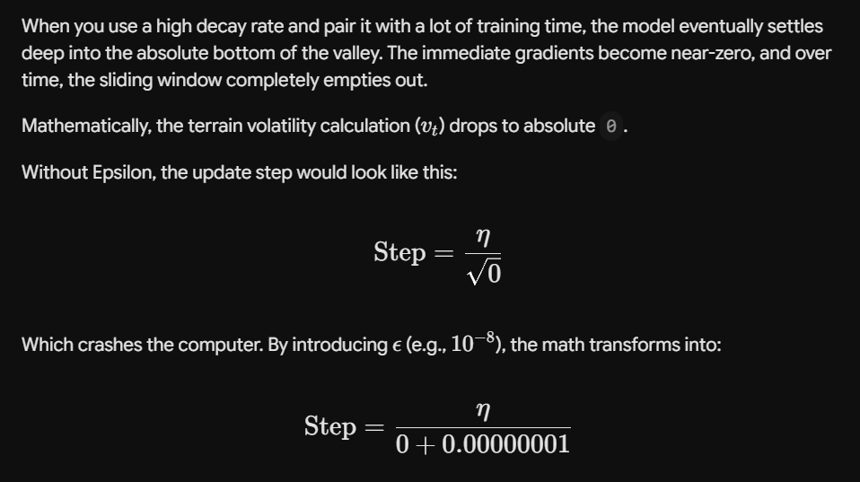
- Lower values (1e-8): Lower, more refined learning breakpoint.
- Higher value: Higher, earlier learning breakpoint. Ideal for at-scale model training with hardware adjustments.
However, since its job is to prevent zero divisions from vanishing gradients, the epsilon could have been just a constant right? Why is it adjustable then?
The epsilon introduces 2 potential issues once models are being trained for scale.
- When training massive modern AI models, engineers often switch from standard 32-bit floating-point math (float32) to 16-bit math (float16 / bfloat16) to save memory and speed up training on modern GPUs. When the hardware precision is reduced to 16-bit, the computer's ability to represent incredibly small numbers shrinks drastically. In 16-bit, the smallest positive number the computer can physically comprehend before rounding it down to pure zero is roughly 6e-5. If this value was a constant, then the 16-bit flops will still see the base epsilon as a 0, and it won’t prevent zero division in the first place.
- Once the model has essentially reached vanishing gradient or flat terrain (decay rate could not raise the gradient square anymore) and the training hasn’t stopped yet, then the square of the past gradients will eventually reach zero. At zero squares, the remaining denominator is epsilon, and a number divided by a very small number will cause its value to jump. This means the actual step size adjustment at the epsilon’s base value will cause the next step to spike. But, because the gradient is also flat (or near zero), the resulting weight update will also be extremely small:
$$\text{Weight Update}=\text{Actual Step Size}\text{ (}\text{1e8}\text{)}×\text{Current Gradient}\text{ (}\text{1e-8}\text{)}$$So it doesn’t matter how big the actual step size becomes, because the gradient is too smooth for the optimizer to work on, resulting to infinitesimally weight updates anyway. Depending on the dataset used, this might mean missing uncharted gradient terrain over the training period, or undoing all the previous learned values. This epsilon was then made adjustable to catch these scenarios.

L2 Regularization | weight_decay (0)
The L2 Regularization or weight decay is a penalty that can be applied to a model’s weights after the step size is calculated. In case the dataset’s overall loss terrain causes the model to go consistently into overfitting, this parameter can be used to penalize weight changes and reduce that effect to a certain extent. Higher values force the model to find broader, more stable valleys that generalize better to new data. Defaults to 0.

Standard Momentum | momentum (0)
Standard Momentum or just momentum allows injecting a simplified form of SGD-based momentum into the optimizer. While this sounds like how Adam works, the order of operations is slightly different; RMSProp’s momentum setting is applied after the step size has been calculated from the gradients, setting it as a secondary factor to the weight calculation. Adam on the other hand, includes the momentum calculation into the core math from the start. Set this value higher to non-zero (e.g. 0.9) to help push the model’s learning if it’s found to be running into some plateaus or low-sloped hills even in an overall uneven loss terrain. Defaults to 0.

centered (False)
The centered parameter alters the way the memory window calculates the slopes. When enabled, the optimizer subtracts an estimate of the mean gradient before squaring the value. It allows for a more refined estimation of the current gradient’s slope, making the model be more careful in updating step sizes, but increases overall computation time per step during training. Defaults to False.

Ideal Working Conditions
When deciding when to use or avoid the RMSProp optimizer, the following questions should be considered:

Is the training data sparse?
Sparse datasets such as product listings with over 10000 products but with few very customer reviews per product, or Natural Language processing concerns that allow multiple tokens per row but have highly varied word counts can be considered sparse data. These datasets can potentially trip up learning models by containing multiple peaks and valleys in the loss terrain. RMSProp allows the model to push through these irregularities using the memory window process, letting the model keep on learning until a more consistent convergence area is reached over time.

Is the loss terrain volatile or unpredictable?
Relative to the first question - all sparse data have volatile loss terrain, but not all volatile loss terrain is due to sparse data. Sometimes, even dense datasets still prove to be challenging to train on, but this is an emergent property. The gradient volatility usually comes up after several training attempts have been made and a glimpse of the training landscape can be observed from the dataset involved. In such case, RMSProp can be used to build upon the current optimizer used, or to create a variance and bump up the learning process.

Does the model involve a standard Computer Vision Network (CNN)?
Computer vision training data can vary heavily on the type of images used for the model, but also predictable enough for the model to know that it’s only dealing with largely the same information (pixel data). That means the loss terrain may or may not be volatile for the current training instance, but choosing the right optimizer from the get-go would save engineers or researchers time and effort in setting up ideal parameters for their model. RMSProp is one of the ideal choices in this case – providing a robust optimizer enough for the computer vision model to move over unseen loss terrain for multiple training sessions.

So why not choose RMSProp consistently then?
While RMSProp is an overall robust optimizer, it does have some flaws:

It underperforms in flat or smooth gradient curves
RMSProp is excellent for allowing models to learn over jagged gradients, but this doesn’t mean the model doesn’t learn with RMSProp on such surfaces. Rather, the learning speed turns into a crawl. This means more epochs wasted on learning slowly when the model could have reached convergence faster on a given dataset. This is akin to an ATV (All-Terrain vehicle) trudging through uncharted or unpredictable landscape mapping every potential value in a dataset, but wasting fuel driving slowly on paved roads or gradual slopes.

It causes models to be prone to overfitting
Because RMSProp allows the model to capture nooks and crannies in a dataset’s loss terrain, it is prone to learning the relationship of almost all points in the dataset, including noise and outliers. This works great for sparse data, but becomes a liability for inherently noisy data such as blurry, speckled or busy images, multiple related or conflicting features, or generally raw, unlabeled data. The optimizer will probe almost every possible bump and hiccup through the learning process, so for datasets with unavoidable or necessary outliers, it will spend extra effort understanding such outliers and potentially learning relationships that aren’t needed in the first place.

Methodology
The RMSProp study went through the following stages.

Stage 1: Preparation
Preparation included the following steps:
- Preparing the dataset
- Defining global constants & variables
- Setting up the base model class & architecture
- Defining shared function definitions
- Setting up the optimizer configuration list
The dataset used came from the KMNIST library using the kuzushiji character data. The prepared dataset consisted of 60000 rows for training and 10000 for testing, both having standard sizes of 28 x 28.
The global constants and variables included the seed ID, directory for the downloaded dataset, Total epoch sizes, batch size per epoch, number of folds and target accuracy. These values remained the same across the extent of the study, but could be adjusted if challenges were encountered during the study.
The base model class and architecture was a standard FeedForwardNet inheriting from the Pytorch neural network module. It had the following structure:
Input (784) > HL 1 128) > Batch Normalizer > ReLU > Dropout (0.2) >
HL2 (64) > Batch Normalizer > ReLU > Dropout (0.2) > Output(10)
The shared function definitions included the cross validation operation and epoch sequencing operation. These functions could be modified to apply functionality specific to the optimizers under study such as metric collection.
Steps one to four were conducted via a base template jupyter notebook shared across 3 different optimizers under study (RMSProp, Adam, AdamW). All 3 optimizer shared the same dataset with K-fold slicing logic, Model Architecture, Training sequence, environment and metrics collection for plotting. The only difference RMSProp included was applying Optuna as a separate config cycler for hyperparameter optimization.
The configuration list setup involved creating a list of hyperparameters to cycle through the training process on the same model. The list included 9 different combinations of hyperparameters native to the RMSOptimizer, using the parameters provided in the parameters section.
These were the 9 configs as listed:
- lr: 0.01, alpha: 0.99, eps: 1e-8
- lr: 0.01, alpha: 0.99, eps: 1e-8, momentum: 0.9
- lr: 0.01, alpha: 0.80, eps: 1e-8
- lr: 0.001, alpha: 0.99, eps: 1e-8
- lr: 0.0001, alpha: 0.99, eps: 1e-8
- lr: 0.01, alpha: 0.99, eps: 1e-8, weight_decay: 1e-4
- lr: 0.01, alpha: 0.99, eps: 1e-8, weight_decay: 1e-3
- lr: 0.01, alpha: 0.99, eps: 1e-8, weight_decay: 1e-2
- lr: 0.01, alpha: 0.99, eps: 1e-07, momentum: 0.003
One exception to the study was the “centered” parameter as it resulted to higher training times per epoch with no significant difference to the model’s performance. In the interest of time, this was removed from the config collection.

Stage 2: Execution
The model training was then executed in phases. First, the model was verified to work in shorter epochs and that the k-fold logic was ensured to work across all folds & epochs per fold. After initial evaluation, the official test execution was carried out, using 20 epochs per fold resulting to 100 epochs per configuration. The config list was iterated and metrics were recorded per iteration. After execution, the best config was evaluated according to the highest overall validation accuracy.
For the Optuna hyperparameter validation, a cycler study was instantiated with Optuna’s study object. An objective function called was defined to be passed into the object as the callback. This callback function would require a dictionary of parameters with values containing Optuna’s suggest_float function. Each suggest float call would have a minimum, maximum and a logarithmic check (log=True) for parameters requiring uneven spaced updates. Once the cycler object runs the “optimize” function, it will collect the best parameters and best values as keys, which can be collected for evaluation.

Stage 3: Data Collection & Evaluation
Training and Testing losses were collected on the first fold of each config run as the baseline. For both the manual config list and Optuna, the best config was determined using the full set that produced the best validation accuracy. However, Optuna was able to test more combinations using the n_trial parameter set to 20. The combination sets were recorded for data visualization.

Data and Results

LR | alpha | eps | momentum | weight_decay | TR acc (%) | VAL acc (%)
0.01 | 0.99 | 1e-08 | n/a | n/a | 95.54 | 96.06
0.01 | 0.99 | 1e-08 | 0.9 | n/a | 90.08 | 93.99
0.01 | 0.8 | 1e-08 | n/a | n/a | 94.26 | 95.58
0.001 | 0.99 | 1e-08 | n/a | n/a | 95.91 | 96.00
0.0001 | 0.99 | 1e-08 | n/a | n/a | 92.33 | 94.45
0.01 | 0.99 | 1e-08 | n/a | 0.0001 | 90.03 | 94.21
0.01 | 0.99 | 1e-08 | n/a | 0.001 | 83.44 | 89.72
0.01 | 0.99 | 1e-08 | n/a | 0.01 | 73.16 | 81.49
0.01 | 0.99 | 1e-07 | 0.003 | n/a | 95.53 | 95.87
Table. 1 Training Loss per Hyperparameter Configuration (Manual)
ID | LR | alpha | eps | momentum | weight_decay | TR acc (%) | VAL acc (%)
config_1 | 0.00195 | 0.8 | 1.14E-07 | 0.3702 | 0.00842 | 84.26 | 89.76
config_2 | 0.00027 | 0.8025 | 4.20E-09 | 0.3709 | 0.00029 | 94.62 | 95.42
config_3 | 0.02664 | 0.8033 | 9.27E-09 | 0.0847 | 0.00136 | 73.04 | 81.06
config_4 | 0.03498 | 0.9781 | 4.98E-07 | 0.0887 | 0.00122 | 69.89 | 79.64
config_5 | 0.00116 | 0.8218 | 2.22E-09 | 0.743 | 1.05E-05 | 94.29 | 95.53
config_6 | 0.00077 | 0.9043 | 9.41E-08 | 0.6739 | 0.00191 | 89.98 | 93.73
config_7 | 0.00023 | 0.894 | 4.41E-08 | 0.0824 | 0.00043 | 94.33 | 95.17
config_8 | 1.24E-05 | 0.9789 | 2.02E-09 | 0.0908 | 2.83E-05 | 83.31 | 87.69
config_9 | 0.00026 | 0.8039 | 3.99E-08 | 0.4143 | 9.60E-05 | 94.64 | 95.38
config_10 | 0.00019 | 0.8016 | 1.06E-09 | 0.1199 | 0.00055 | 94.00 | 95.06
config_11 | 0.00601 | 0.86 | 7.38E-07 | 0.8712 | 1.03E-05 | 85.70 | 91.56
config_12 | 3.56E-05 | 0.8478 | 4.84E-09 | 0.5868 | 9.91E-05 | 91.44 | 93.89
config_13 | 0.00342 | 0.8412 | 7.39E-09 | 0.8623 | 9.98E-05 | 84.46 | 90.53
config_14 | 0.00081 | 0.8385 | 2.99E-09 | 0.3179 | 1.15E-05 | 95.24 | 95.81
config_15 | 0.00088 | 0.8825 | 1.08E-09 | 0.6248 | 1.06E-05 | 95.17 | 95.78
config_16 | 6.24E-05 | 0.8934 | 1.06E-09 | 0.5077 | 2.74E-05 | 92.80 | 94.55
config_17 | 0.01014 | 0.9244 | 1.33E-08 | 0.2142 | 2.94E-05 | 91.06 | 94.39
config_18 | 0.00059 | 0.8699 | 2.92E-09 | 0.2378 | 1.75E-05 | 95.31 | 95.63
config_19 | 0.01037 | 0.9359 | 1.77E-08 | 0.5307 | 5.48E-05 | 87.03 | 92.32
config_20 | 0.08865 | 0.8779 | 1.04E-09 | 0.7404 | 5.29E-05 | 48.26 | 62.43
Table. 2 Training Loss per Hyperparameter Configuration (Optuna - 20l)

Config ID | Optuna Parameter Configuration
config_1 | lr: 0.0019476838464710998, alpha: 0.800025289324904, eps: 1.1392983025644397e-07, momentum: 0.3701973165945234, weight_decay: 0.008424534983398027
config_2 | lr: 0.0002705494845786357, alpha: 0.8024846649464388, eps: 4.198054585997742e-09, momentum: 0.37094913506955823, weight_decay: 0.0002894154724905874
config_3 | lr: 0.026640584134882614, alpha: 0.8032514072130412, eps: 9.270481985035688e-09, momentum: 0.0846827861457791, weight_decay: 0.001360555088824136
config_4 | lr: 0.034980420096149156, alpha: 0.9781040889843617, eps: 4.979793789604447e-07, momentum: 0.08872365680660942, weight_decay: 0.0012181438359676958
config_5 | lr: 0.0011600597275032583, alpha: 0.8218467767968733, eps: 2.2189459466856255e-09, momentum: 0.742988986089937, weight_decay: 1.0528704406305239e-05
config_6 | lr: 0.000768535818087759, alpha: 0.9042889462647967, eps: 9.41157015652493e-08, momentum: 0.673943614017454, weight_decay: 0.0019084424978012544
config_7 | lr: 0.0002334045588745601, alpha: 0.8940495196165702, eps: 4.4149719128883496e-08, momentum: 0.08237981675673965, weight_decay: 0.00042734085143992894
config_8 | lr: 1.2404761911649825e-05, alpha: 0.9788952427470539, eps: 2.024479373363253e-09, momentum: 0.0907740093921802, weight_decay: 2.829317153761786e-05
config_9 | lr: 0.0002550150677454392, alpha: 0.80389512838779, eps: 3.986609347193261e-08, momentum: 0.4143386878657271, weight_decay: 9.601853921513595e-05
config_10 | lr: 0.00019303211473271065, alpha: 0.8016473102350582, eps: 1.0647457307653659e-09, momentum: 0.1198568520124796, weight_decay: 0.0005523698410613538
config_11 | lr: 0.006011183112880236, alpha: 0.8599834287351458, eps: 7.376919810051015e-07, momentum: 0.8711558869622029, weight_decay: 1.0265162904399288e-05
config_12 | lr: 3.5621346912319085e-05, alpha: 0.8477740400140249, eps: 4.84430111698863e-09, momentum: 0.5868313213886879, weight_decay: 9.914886573284521e-05
config_13 | lr: 0.0034203568468211955, alpha: 0.8411710612200827, eps: 7.387250959134082e-09, momentum: 0.8623258136563945, weight_decay: 9.980396672648531e-05
config_14 | lr: 0.0008147881236065796, alpha: 0.8385344255851751, eps: 2.9884607395327503e-09, momentum: 0.31785473211953924, weight_decay: 1.1508825568035366e-05
config_15 | lr: 0.0008837377743583721, alpha: 0.8824966424677287, eps: 1.0832281439392694e-09, momentum: 0.6248377417848384, weight_decay: 1.0567445644797476e-05
config_16 | lr: 6.238519405532185e-05, alpha: 0.8933857765547827, eps: 1.062935454079886e-09, momentum: 0.5076616613931555, weight_decay: 2.738803779912171e-05
config_17 | lr: 0.010139043461371558, alpha: 0.9243817924969993, eps: 1.3303985420504914e-08, momentum: 0.21424910543600087, weight_decay: 2.9396934588483122e-05
config_18 | lr: 0.000589660205181521, alpha: 0.8699150195184332, eps: 2.919906946131479e-09, momentum: 0.23781766261182363, weight_decay: 1.7508689909851672e-05
config_19 | lr: 0.01037420938580816, alpha: 0.9358530901270731, eps: 1.7719748836962326e-08, momentum: 0.5307023721463947, weight_decay: 5.483216492741157e-05
config_20 | lr: 0.08865248939830234, alpha: 0.877904111217427, eps: 1.0372615023712756e-09, momentum: 0.7403977275232295, weight_decay: 5.28516736707329e-05
Table. 3 Config ID Hyperparameter Lookup Table (Optuna - 20)

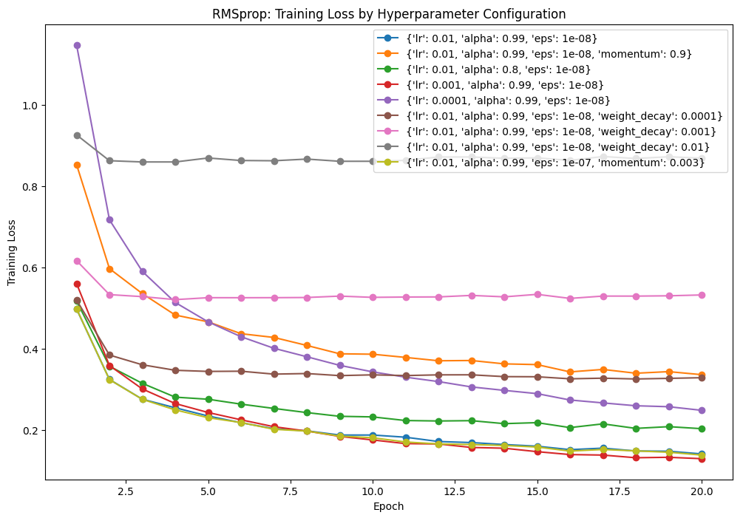Fig. 1 Training Loss per Hyperparameter Configuration (Manual)
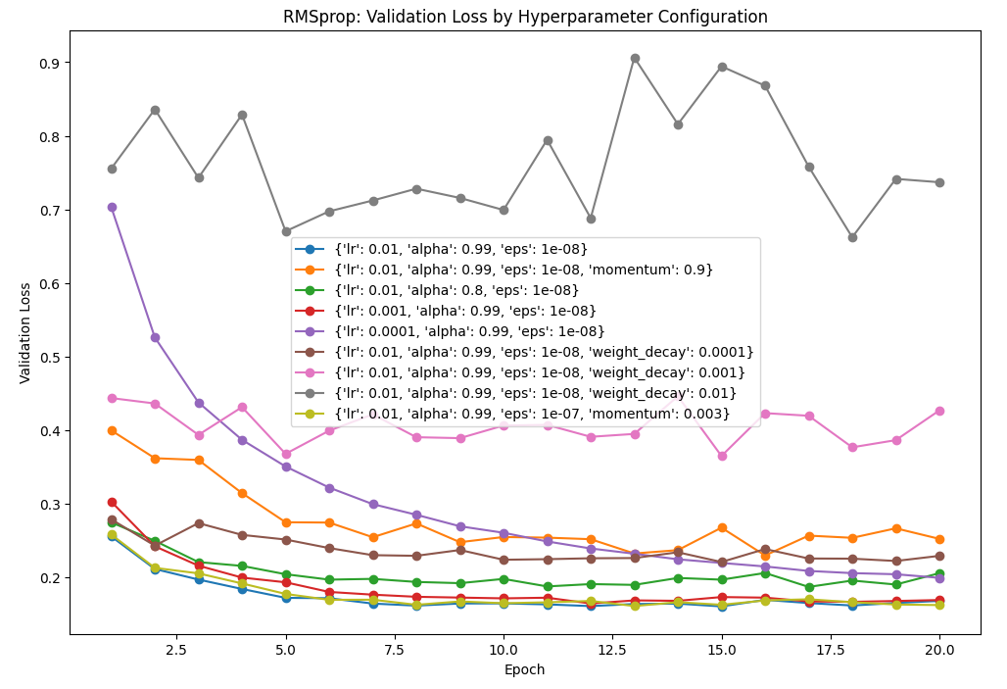
Fig. 2: Validation Loss per Hyperparameter Configuration (Manual)

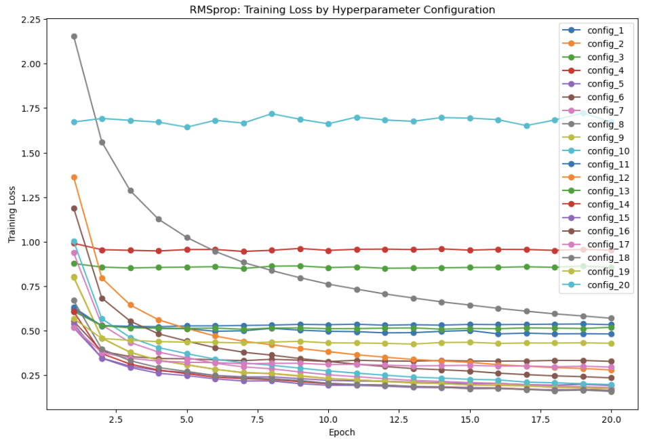
Fig. 3: Training Loss per Hyperparameter Configuration (Optuna - 20)

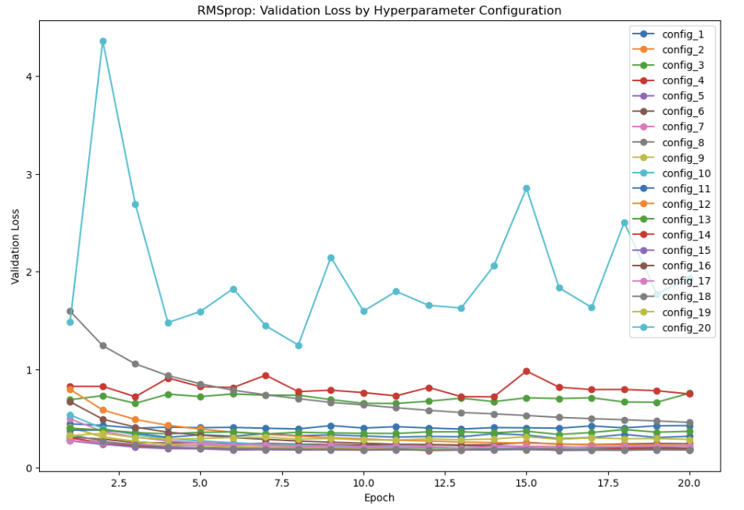
Fig. 4: Validation Loss per Hyperparameter Configuration (Optuna - 20)

Interpretation

Manual Training Accuracy
Figure 1 shows the different training loss trends captured for the manually-listed configurations. The best configuration recorded was still the baseline set of values (Blue) after execution. However, Red showed the most learning potential, having reached the lowest loss rate by epoch 20.
Almost all of the trends presented the expected elbow graph with loss reduction over time, indicating that the parameters allowed degrees of training for the model. The configs showing the least amount of learning would be Gray and Pink, flatlining almost immediately by epoch 2. Following closely is brown which showed a slight decrease after epoch 2 but also plateauing immediately. All 3 configs involve the weight_decay parameter as part of the settings. Orange also showed some degree of variance (slight jaggedness) between losses per epoch.

Manual Validation Accuracy
Figure 2 shows the different validation loss trends captured for the manually-listed configurations. The best configuration recorded was still the baseline values (Blue), however different config combinations showed interesting plots over epochs. For instance, for the brown, magenta and gray configs, their plots all show some level of variance. This can be attributed to the “weight_decay” parameter changed among the 3. In fact, the higher the weight decay, the higher the loss jumps got, with gray showing the most unpredictability at 0.01 weight decay. Orange also showed some level of loss variance with almost no growth over epochs, due to the momentum set too high (0.9). Conversely, purple provided the smoothest graph due to having the lowest learning rate, but requiring more epochs per fold to reach convergence.

Optuna Training Accuracy
Figure 3 shows the different training loss trends captured for the Optuna 20-config list. While majority of the combinations showed the gradual training loss improvement overtime, some noteworthy combinations appear that showed unstable signs. First off, config_20 which also had the worst training-validation accuracy ratio in Table 2, also showed a plot with basically erratic growth. This can be attributed to its learning rate value being too high from the baseline (0.088). Another poor performer was config_3, which while having an average of 0.8 training loss, it had a training plot plateauing immediately with little-to-no growth. This may be likely to its relatively high LR and momentum values. We also have config_8 (higher gray) which may have a nice gradual elbow downward, started with way too high training error loss and not enough convergence by epoch 20. Config_8 had a very low learning rate but relatively higher momentum, causing it to have substantial improvement over time but starting with too shallow values and requires more epoch - a stark contrast to config_3’s setup.

Optuna Validation Accuracy
Figure 4 shows the different validation loss trends captured for the Optuna 20-config list. Optuna picked Config_14 as the best config from the set (95.81%), while our manual collection picked Config_15 as the best (95.78) – not too far off from the actual result, and both having good training-to-validation accuracy ratios. Optuna’s validation plots mirrored that of its training plots, showing how erratic config_20’s validation losses are given its shallow training curve. Config_4 and 3 also showed erratic validation loss plots, basically guessing the results and not providing any learning insights also reflecting their respective training plots. The rest of the plots however showcased good validation curves with relatively low losses, indicating Optuna’s TPE algorithm’s optimal efficiency.

Discussions
Following the data collection and evaluation for RMSProp’s different parameters, each parameter had varying effects on overall training. The effects however have different impacts, which were rated through visual inference.
Each parameter is also rated out of 5 regarding its effect and impact to model training and validation, with 5 having the most effect on the training. The rating is purely inferential and does However, this rating criteria is only based on the effect of the parameter on the model’s resulting training and testing accuracy. It excludes total training time, model runtime performance and dataset quality.

Learning Rate: 5 / 5
Being the main parameter common for all optimizers, it is expected that the Learning Rate has the most effect on the resulting accuracy and losses for the model in study. It is generally also the parameter primarily adjusted for model training. It is advised to adjust Learning Rate first if trying to look for model convergence point, and varying it accordingly for faster or more focused model training.

Alpha: 3 / 5
The Alpha had some limited effect to the model. Reducing the memory window caused the model to get docked in training accuracy, but did not severely affect the validation accuracy. Considering that this value uses the lookback strategy to adjust the model weights, it confirms this observation in that only the training accuracy was more affected. That is, the model can still have good validation rating regardless of how it was trained. The overall effect of the alpha is relatively low for this study’s conditions, but can potentially have better results with more unpredictable dataset qualities.

EPS: 2 / 5
The EPS is usually observed if the model’s validation losses tend to plateau almost immediately or sporadically when using the optimizer. In the case study however, the dataset is not too variant to force the model into this situation, therefore introducing change into this value had little effect to the overall training and validation accuracy. Its usage may shine if datasets with different qualities were also cycled through the training, but as of this study’s conditions, its impact rating is low and adjusting it won’t affect the model training heavily.

Momentum: 4/5
The Momentum also had some relative effect on the overall model result like the Alpha, but with more impact. Introducing a higher value to the momentum docked at least 2 points to the resulting validation accuracy and at least 5 to the training accuracy. However, having smaller values didn’t penalize nor improve the resulting accuracies either. This hints that momentum can be treated as a secondary parameter to introduce to help push the model’s training further, but to keep it disabled if it’s doing well enough.

Weight Decay: 5/5
As shown from the tables and graphs, slight adjustments to the weight decay already penalized the model training heavily. A very small value introduced to the optimizer already docked the resulting validation accuracy by at least 1% from the base config setting. Increasing the value further resulted in higher drops as well (94% -> 89% -> 81%). This shows how much impact weight decay introduces to training and when it is best used. Ideally, weight decay should only be introduced if the model is prone to overfitting with staggering validation losses, therefore this parameter should be used with caution and best set to 0 by default.

Centered: 1/5
Since Centered was not explored heavily during the study, this evaluation is simply limited to earlier trial runs of the model where it produced more training time per epoch when enabled. Considering that the model could immediately reach high training and validation accuracies for this study, we could say that the dataset is relatively stable, predictable and easy enough to train the model on. Enabling Centered would only refine the weight calculation of the optimizer resulting to more calculations and more training time, but providing no major benefit as a tradeoff. Its rating is set to 1 / 5, advising only to enable as an exploratory option rather than an immediate choice for parameter optimization.

Optuna
The use of Optuna’s hyperparameter optimization logic allowed for a good number of combinations to play around with at high-granularity changes. Compared to manual sampling which limits us to base values with fixed steps or controlled randomization, Optuna’s TPE algorithm lets it run a tree structure with Bayesian optimization to adjust needed parameters to the best possible results similar to Sagemaker’s HPO tuning jobs. Letting Optuna run for a while to search for optimal hyperparameter combinations would save time and effort in searching for the best hyperparameters for a given training job.

Conclusions
The RMSProp is generally stable optimizer used as the base of the popular Adam algorithm. Its memory window weight calculation method allows the model to push through learning difficult datasets, but can slow down on learning plateaus. Given the parameters available to it, adjusting the Learning Rate (0.01-0.001) as the primary parameter is advised, with using Momentum (0 - 0.001) and Alpha (0.99-0.5) as secondary fine-tuning options. Adding Weight Decay can prove beneficial to training but only with minute, incremental values (0 – 0.001) rather than large deltas. The Epsilon and Centered parameters barely got a chance to shine but this is attributed to the dataset’s quality for easy training and learning traversal.
We advise to use the preset base values for the RMSProp’s algorithm, as these are the industry standard accepted values, and adjusting the parameters according to the order stated above. We also advise to invest in some time running a tuning job like Optuna for major training jobs to save time and effort producing models that can reach their required goals.

References:
- RMSProp Documentation, pytorch.org https://docs.pytorch.org/docs/2.12/generated/torch.optim.RMSprop.html
- RMSProp Optimizer in Deep Learning, geeksforgeeks.org, https://www.geeksforgeeks.org/deep-learning/rmsprop-optimizer-in-deep-learning/
- Lecture Notes, Hinton, G. (2012). Lecture 6e, Coursera. https://www.cs.toronto.edu/~tijmen/csc321/slides/lecture_slides_lec6.pdf
- Generating Sequences with Recurrent Neural Networks, Alex Graves, Department of Computer Science University of Toronto https://arxiv.org/pdf/1308.0850v5
- Understanding Loss Surfaces, apxml.com, https://apxml.com/courses/optimization-techniques-ml/chapter-1-ml-optimization-foundations-review/loss-surface-analysis

